Victoria State Committee - A Special End of Year Luncheon
Friday 14th December 2018, 1200-1500
Kooyong Lawn Tennis Club, 489 Glenferrie Road, Kooyong VIC 3144
We would be delighted to have the pleasure of your company on what will be Shipping Australia’s final event of the year. The luncheon includes select entertainment and prizes to be held at the historic Kooyong Lawn Tennis Club (est 1892) home to the Australian National Tennis Titles up until the opening of the National Tennis Centre in 1987.
_____________________________________________________________________________________________
Please reply at the earliest - Seating is limited – book early to avoid disappointment.
Members: $130 per person (incl. GST) or $995 per table of 8 (incl. GST)
Non-members: $135 per person (incl. GST) or $1045 per table of 8 (incl. GST)

- On-line: For on-line payments visit https://shippingaustralia.com.au/events and follow the prompts. Please send confirmation and numbers attending to accounts@shippingaustralia.com.au
- Payments may also be made by completing the registration details (as required) below and emailing to accounts@shippingaustralia.com.au

Please call telephone number 0418 109 099 if clarification is required.

Names:________________________________________________________________________________________________

Company:________________________________________________________ Phone: _______________________________

Email address (for receipt) ________________________________________________________________________________

Direct credit to National Australia Bank, Shipping Australia; BSB 082 001 Account No: 53151 7623

I have enclosed a cheque for $________________________________ for ____________________________________ persons

Please debit my card for $_____________Cardholder’s Name_____________________________________________________

Please circle: Bank Card MasterCard Visa AMEX On-line

Card Number

CCV _________________ Expiry date ____________________ Signature ___________________________________________
(This document will be a tax invoice for GST purposes when you make payment.)
Please note that cancellations within 7 days of the event will not be refunded

The venue is approximately a two minute walk from Kooyong Station. Directions to the Club from the station are as follows:

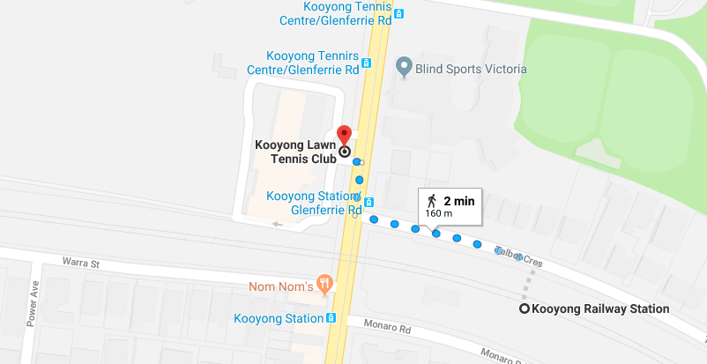

Alternatively, ample parking exists adjacent to the clubhouse.

