**YSA VIC Christmas Party 2016**YSA Victoria members celebrated the end of the year with a Christmas Party held at The Savoy Tavern.   
The establishment has been the host of many great YSA events but sadly was demolished to make way for the growing population of Melbourne.

[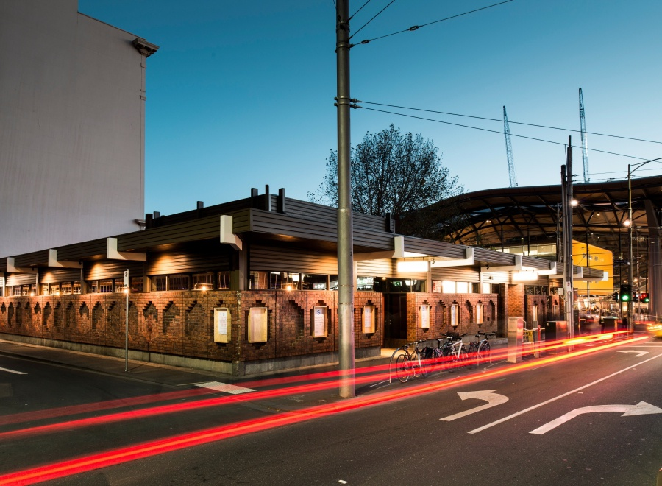](http://www.google.com.au/url?sa=i&rct=j&q=&esrc=s&source=images&cd=&ved=0ahUKEwimmdOBvLTTAhUSJFAKHdgSAW4QjRwIBw&url=http%3A%2F%2Fthesavoytavern.com.au%2F&psig=AFQjCNHGTZARYlXzB_FbE7ykkTnY_mVo1g&ust=1492826977984214)

[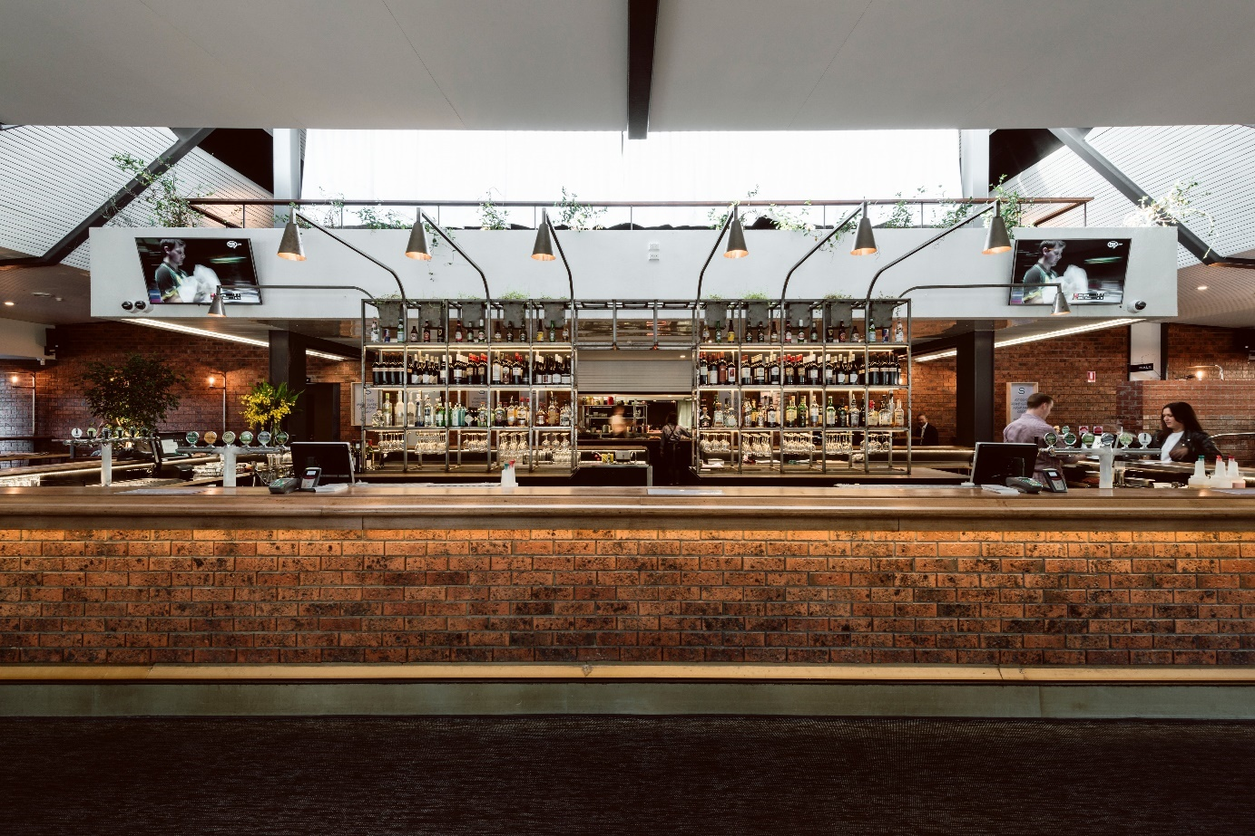](http://www.google.com.au/url?sa=i&rct=j&q=&esrc=s&source=images&cd=&cad=rja&uact=8&ved=0ahUKEwjswKaZvLTTAhUIJFAKHQPfA0oQjRwIBw&url=http%3A%2F%2Fthesavoytavern.com.au%2F&psig=AFQjCNGxEy6gojlY3X2t7qo53Rp89opmbQ&ust=1492827018074612)

